Characterization of functional inorganic materials by X-ray diffraction methods

K. Baltakys, T. Dambrauskas
Kaunas University of Technology, Radvilenu st. 19-236, LT-50524 Kaunas, Lithuania
*Corresponding author, e-mail: kestutis.baltakys@ktu.lt

Rapid advances in material science have been achieved thanks to a variety of new instrumental techniques for characterising the crystal structure of functional inorganic materials and the application of these techniques to quantitative analysis. Recently, the Rietveld method in quantitative phase analysis has been increasingly applied to the analysis of X-ray diffraction profiles of functional inorganic materials and their main constituents, calcium silicate hydrates and/or calcium silicates, etc. The Rietveld quantitative phase analysis is the only method that evaluates crystallographic changes in the components of the material under investigation [1, 2].
The essence of the Rietveld method is that a theoretical model of the crystal structure of the material is calculated using a theoretical diffraction pattern of the material and appropriate shape and background functions for the profile of the diffraction maxima [1, 2]. The intensity values of the calculated and experimental diffraction profiles of the test material at each point are compared with each other and the difference between them is minimised by the least squares method by varying various structural parameters in the initial model. The difference shall be close to zero and, for a fully refined material structure, the calculated diffraction profile shall be similar to that measured experimentally. It is worth highlighting, that Rietveld method is inherently a structure raiment method but not a structure solution method. Therefore, to performer accurate analysis, it is necessary to have an accurate initial structure model for each crystalline phase in the sample.
The quantitative analysis is challenging process for all materials. For example, ordinary Portland cement (OPC) consist of four main phases, alite, belite, tricalcium aluminate, and brownmillerite (Fig. 1).

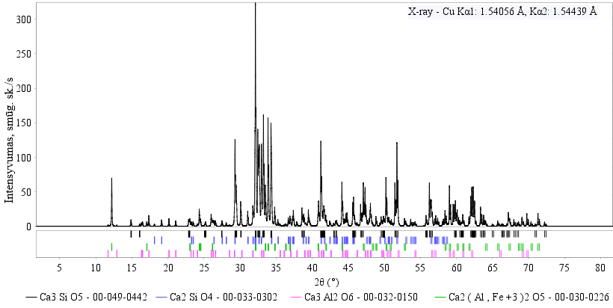
Intensity, cps
Fig. 1. X-ray diffraction analysis pattern of Portland cement clinker sample

During synthesis, foreign ions can intercalate into the structure of mentioned compounds, which complicates the analysis. Therefore, the quantitative Rietveld analysis with 3% error is considered accurate. Even more complex analysis is characterization of OPC hydration products.

References
- Scrivener K., Snellings R., Lothenbach B. (2016). A Practical Guide to Microstructural Analysis of Cementitious Materials: edited book. Boca Raton, FL: Taylor & Francis, 540 p.
- Pecharsky, V.K., Zavalij, P.Y. (2005). Fundamentals of Powder Diffraction and Structural Characterization of Materials. New York: Springer Science+Business Media. 721 p.

