Carbonate Apatite Honeycomb Scaffolds for Bone Regeneration

K. Hayashi^{1,*}
¹Kyushu University, 3-1-1, Maidashi, Higashi-ku, Fukuoka 812-8582 Japan
*Corresponding author, e-mail: khayashi@dent.kyushu-u.ac.jp

As the global population is aging rapidly, healthy life expectancy should accompany this increase. To extend the healthy life expectancy, the maintenance and recovery of oral and locomotory functions are crucial, for which dental implantation and orthopedic bone regeneration are effective.
Scaffolds with uniaxial channels from the bottom face contacting the host bone to the top face, such as honeycomb (HC) scaffolds, are deemed to be favorable for the ingrowth of bone and blood vessels. To date, we fabricated various types of HC scaffolds composed of carbonate apatite (Figure 1), known as a bone mineral analog, by exploiting extrusion molding [1-18]. We demonstrated the effects of the composition [12,16], structure at macro- [3-5,8-14], micro- [17], and nanoscales [15], and shape [1] on osteogenesis and angiogenesis by in vivo evaluations. Carbonate apatite showed a higher osteoconductivity than those consisting of β-tricalcium phosphate and hydroxyapatite [12,16]. Intrascaffold channels of 230−300 μm in apertural size prevented the penetration of fibrous tissues into the scaffold [14], thus providing a dominant position for osteogenesis and angiogenesis [3,4,9]. The micro- and nanopores affected osteoclastogenesis and the subsequent resorption of scaffolds by osteoclasts and new bone formation [15,17]. The scaffolds with both channels and micropores exerted osteoinduction [6] and osteoconduction [7,9], and shortened the bone reconstruction period. Furthermore, even tiny protuberances on the scaffold surface affected the percentage of interscaffold space, thereby exerting dominant effects on osteogenesis [1].
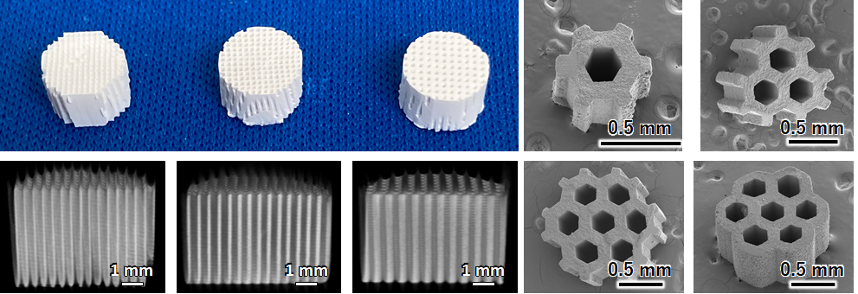
Fig. 1. Various carbonate apatite HC scaffolds.
In addition, we developed the method for providing antibacterial activity to carbonate apatite HC scaffolds [2]. The antibacterial HC scaffolds perfectly prevented bacterial infection in vivo in the presence of methicillin-resistant Staphylococcus aureus, formed new bone at 2 weeks after surgery, and were gradually replaced with a new bone. Thus, the antibacterial honeycomb scaffolds achieved both infection prevention and bone regeneration.

References
- K. Hayashi, T. Yanagisawa, R. Kishida, K. Ishikawa ACS Nano 2022, 16, 11755-11768
- K. Hayashi, M. Shimabukuro, K. Ishikawa, ACS Appl. Mater. Interfaces. 2022, 14, 3762−3772.
- K. Hayashi, T. Yanagisawa, M. Shimabukuro, R. Kishida, K. Ishikawa, Mater. Today Bio 2022, 14, 100247.
- K. Hayashi, M. Shimabukuro, R. Kishida, A. Tsuchiya, K. Ishikawa, J. Adv. Res. 2022, in press, DOI: 10.1016/j.jare.2021.12.010.
- K. Hayashi, A. Tsuchiya, M. Shimabukuro, K. Ishikawa, Mater. Des. 2022, 215, 110468.
- K. Hayashi, K. Ishikawa, Nano Select 2022, 3, 60−77.
- K. Shibahara, K. Hayashi, Y. Nakashima, K. Ishikawa, Front. Bioeng. Biotechnol. 2022, 10, 825831.
- K. Hayashi, N. Kato, M. Kato, K. Ishikawa, Mater. Des. 2021, 204, 109686.
- K. Hayashi, K. Ishikawa, ACS Appl. Bio Mater. 2021, 4, 721−730.
- Y. Sakemi, K. Hayashi, A. Tsuchiya, Y. Nakashima, K. Ishikawa, J. Biomed. Mater. Res. 2021, 109, 1613–1622.
- K. Shibahara, K. Hayashi, Y. Nakashima, K. Ishikawa, ACS Appl. Bio Mater. 2021, 4, 6821–6831.
- K. Hayashi, R. Kishida, A. Tsuchiya, K. Ishikawa, ACS Appl. Bio Mater. 2020, 3, 1787−1795.
- K. Hayashi, M. L. Munar, K. Ishikawa, Mater. Sci. Eng. C-Mater. Biol. Appl. 2020, 111, 110848.
- K. Hayashi, M. Shimabukuro, R. Kishida, A. Tsuchiya, K. Ishikawa, Mater. Adv. 2021, 2, 7638−7649.
- K. Hayashi, K. Ishikawa, J. Mater. Chem. B 2020, 8, 8536−8545.
- K. Hayashi, R. Kishida, A. Tsuchiya, K. Ishikawa, Mater. Today Bio. 2019, 4, 100031.
- K. Hayashi, R. Kishida, A. Tsuchiya, K. Ishikawa, Adv. Biosyst. 2019, 3, e1900140.
- K. Hayashi, M. L. Munar, K. Ishikawa, Ceram. Int. 2019, 45, 15429−15434.

