Effect of Silver to Magnetite Properties in Ag/Fe₃O₄ nanoparticles composite

L. Mikoliunaite^{1, 2*}, M. Talaikis¹, G. Zambzickaite¹, G. Niaura¹
¹Center for Physical Sciences and Technology, Department of Organic Chemistry, Sauletekio av. 3, LT-10257, Vilnius, Lithuania
²Vilnius University, Faculty of Chemistry and Geosciences, Naugarduko st. 24, LT-03225, Vilnius, Lithuania
*Corresponding author, e-mail: lina.mikoliunaite@ftmc.lt

Bifunctional magneto-plasmonic nanoparticles that exhibit synergistically magnetic and plasmonic properties are advanced substrates for surface-enhanced Raman spectroscopy (SERS) due to their excellent controllability and improved detection potentiality. Surface-enhanced Raman spectroscopy [1] is known for its sensitivity to detect extremely low concentrations of analytes. Rough noble metal structures, such as silver and gold nanoparticles provide plasmon resonance that enhances Raman signal allowing to detect the analyte at concentrations as low as 10⁻⁹ M. However, this method has some difficulties, such as low analyte concentration and large solution volumes hamper the detection of Raman spectrum or require long acquisition time. One solution, suggested by scientists and dedicated for sample concentration, was to supplement plasmonic properties having particles with magnetic properties by preparing noble metal-coated or decorated nanocomposites [2-5]. The magnetic part of the composite allows concentrating material together with adsorbed analyte while plasmonic silver/gold part provides the SERS signal.
In this work 50 nm size magnetite nanoparticles were decorated with 13 nm size silver nanoparticles and their optical properties were investigated. It was noticed, that not only analyte’s signal is enhanced in the presence of AgNP, but magnetite nanoparticles are affected as well. Usually, the heating of the sample is present during the illumination of the laser. The heating of magnetite results in the change of its crystallographic structure, which at certain temperatures changes to the hematite form. However, due to attached silver nanoparticles, magnetite was able to endure higher power of laser radiation. In addition to this, we estimated the SERS enhancement factors of hybrid nanoparticles for five laser excitations, with the highest found for 633 nm to be 3.1 × 10⁷.

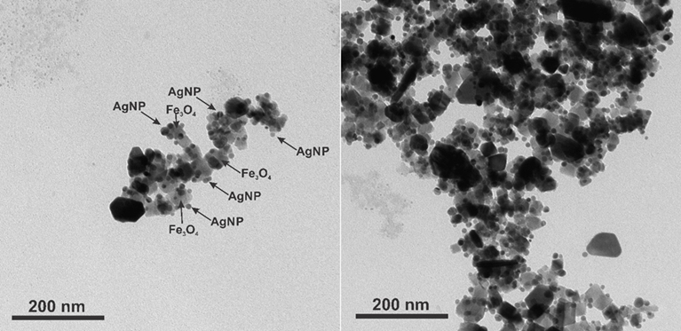
Fig. 1. TEM images of cubic magnetite covered with spherical silver nanoparticles.

References
- J. Langer, D.J. De Aberasturi, J. Aizpurua, R.A. Alvarez-Puebla, B. Auguié, J.J. Baumberg, G.C. Bazan, S.E.J. Bell, A. Boisen, A.G. Brolo, A.G.; et al., ACS Nano, 14 (2020) 28–117.
- K.-H. Huynh, E. Hahm, M.S. Noh, J.-H. Lee, X.-H. Pham, S.H. Lee, J. Kim, W.-Y. Rho, H. Chang, D.M. Kim, et al., Nanomaterials, 11 (2021) 1215.
- C. Wang, M.M. Meloni, X. Wu, M. Zhuo, T. He, J. Wang, C. Wang, P. Dong, AIP Advances, 9 (2019) 010701.
- M. Gühlke, S. Selve, J. Kneipp, J. Raman Spectrosc., 43 (2012) 1204–1207.
- H. Lai, F. Xu, L. Wang, J. Mater. Sci., 53 (2018) 8677–8698.

