How to use ionic liquids to make inorganic nanomaterials

A.-V. Mudring*
¹Department of Chemistry and iNANO, Aarhus University, Langelandsgade 140, 8000 Aarhus C, Denmark
*A.-V. Mudring, e-mail: anja-verena.mudring@chem.au.dk

Nanomaterials have become indispensable for modern life. Many technologies depend critically on nanomaterials with engineered properties and structures, particularly those related to clean energy applications such as photocatalysts, light phosphors, thermoelectrics and others. Technological borders could be pushed further and improved materials would become available if more powerful tools for the tailored synthesis of nanomaterials could become available. In this, ionic liquids (ILs, room temperature molten salts) have the potential to become a true game changer. These unconventional solvents are permitting more efficient, safer and environmentally benign preparation of high quality products.
ILs, which can be built by a wide variety of cation-anion combinations with different functionalities, can act as the reaction medium, particle stabilizing and templating agent all-in-one, sometimes even as the reaction partner. IL based nanomaterial synthesis is faster, safer, and more energy- and atom-efficient than comparable methods. It uses less toxic chemicals, omits the use of auxiliary substances such as stabilizers, and minimizes waste. Through coupling with unconventional synthetic routes (physical vapor deposition, microwaves, ultrasound) that take advantage of their unique properties, ILs become even more powerful in nanomaterials synthesis (Fig. 1).
Because of their high modularity, ILs can be tailored for a specific synthesis through chemical structure variations unlike any conventional solvents. Unique to ILs is their truly multifunctional character, which allows them to serve more than just as the solvent and reaction medium. With ILs properties and property combinations can be achieved that are unattainable from conventional solvents. This also allows to use unconventional synthetic methods and develop new techniques. It is expected that the presented, universal methods for the production of nanomaterials from ILs, will allow for the manufacturing of improved products and devices and open up new horizons for nanosynthesis. The methods are generally, faster, safer, more energy- and atom (material)-efficient, use less and less toxic chemicals, negate the use of auxiliary substances (such as surfactants and stabilisers), reduce the risk of pollution, reduce and prevent waste, thus, reduce the risk to human health and minimise the impact on the environment, yet are economically viable. In addition, these unconventional production methods allow us to develop new and improved nanomaterials, pertinent for a wide number of applications such as catalysis and wastewater treatment, solar cells and solid-state lighting as well as biomedicine.
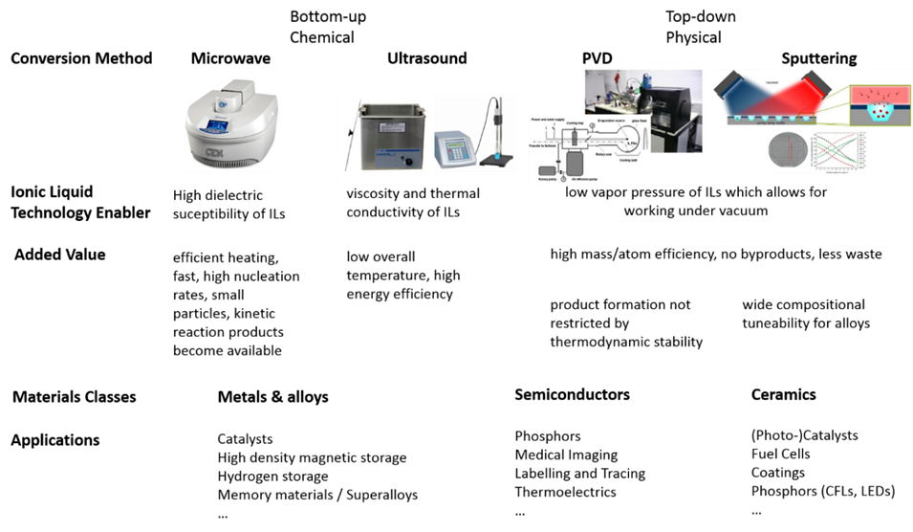

Fig. 1. Bottom-up vs. top-down methods for the synthesis of nanomaterials from ionic liquids.
.
References
- O. Hammond, A.-V. Mudring, Chem. Commun. 58 (2022) 3865-3892 and references therein.

